Program: EUROPE FOR CITIZENS
Project title: Active citizens for active climate protection
The project “Active citizens for active climate protection” aims to raise the awareness among the citizens regarding the importance of getting active themselves to protect the climate. Moreover, it aims to show, that the already active citizens are not alone with their effort and commitment – that other citizens in other countries of the EU work actively for the same aim. There are different ideas and approaches in the diverse countries, which have the power to inspire and motivate alike for continuing and improving existing activities and developing new approaches. The cross-national exchange in this field, which is possible in the course of this project, enhances the European community spirit and strengthens the citizens’ identification with the EU and at the same time contributes to reach the EU climate and energy (20-20-20) targets. In this project, partners from five EU countries (Austria, Czech Republic, Malta, Portugal, and Spain) will work jointly to contribute both to the 20-20-20 targets and the targets of the “Europe for citizens”-programme.
The core element of the project is the organisation of five 2-day-events (one in each participating country) including excursions to national good practices and a big public event, where citizens will be involved in different intensities (international participants, national participants and indirectly involved citizens). A special focus will be on the suitable, attractive design of the public events, so that it is appealing to young and older citizens alike. The events should offer adequate facilities to present the partner countries’ good practices and the EU’s targets and efforts in the climate sector as well as facilities to discuss exchange and jointly develop ideas.
Dates of the events:
- Austria (region Wagram): 17th – 18th September 2015
- Spain (city of Badajoz): 25th – 26th February 2016
- Malta (city of Marsa): 12th – 13th May 2016
- Czech Republic (city of Prague): 02nd – 03rd June 2016
- Portugal (city of Espinho): 22nd – 23rd September 2016

The project "Active citizens for active climate protection" was funded with the support of the European Union under the programme "Europe for citizens".
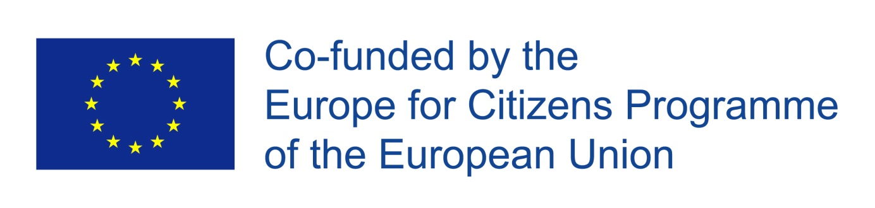
More information on the use of the logo and download: https://eacea.ec.europa.eu/about-eacea/visual-identity_en

